**Partial Retirement Opportunities and the Labor Supply of Older Individuals[1]**

Tunga Kantarcı[2], Jim Been[3], Arthur van Soest[4], Daniel van Vuuren[5]

March 2024

**Summary**

Many countries take policy measures to prolong working lives. The main measure is increasing the statutory retirement age. A higher statutory retirement age implies higher labor participation among older people, a longer period of tax and social security contributions, and a shorter period of pension claims. However, not everyone will be willing or able to work full-time until the higher state pension age. While some may retire and claim an early occupational pension or use their accumulated non-pension wealth, others may not stop working completely but reduce the number of hours they work and combine a partial pension with part-time earnings as their state pension eligibility age is delayed.

Using data on stated choices among a variety of retirement scenarios involving different forms of partial and full retirement with varying financial incentives, we estimate a life-cycle model to analyze how the decisions to retire, work part-time, or work full-time, change if the statutory retirement age is increasingly delayed, if pension accruals increase, if different partial retirement opportunities are introduced, or when partial retirement is encouraged by special financial incentives, such as the Dutch “*Generatiepact*”. We show that, as expected, a higher statutory retirement age makes actuarially fair (abrupt) early retirement more attractive and makes late retirement less attractive, while for any statutory retirement age, about one in three respondents prefer partial retirement. Partial retirement becomes more attractive than full retirement if delaying retirement is rewarded with higher pension accruals. Early retirement becomes more attractive than late retirement when individuals do not have the partial retirement option, demonstrating the potential of partial retirement as a policy instrument to stimulate labor participation, especially when the statutory retirement age is increased. When wage compensation and pension accrual during partial retirement are subsidized, partial retirement becomes more attractive. Several variants of the Dutch *Generatiepact* and *Vitaliteitspakket* are shown to have a positive net effect on total hours worked. However, this result cannot be generalized to all subsidized partial retirement plans.

**Samenvatting**

Veel landen nemen beleidsmaatregelen om ouderen langer te laten doorwerken. De belangrijkste maatregel is het verhogen van de wettelijke pensioenleeftijd of, in de Nederlandse context, een hogere AOW-leeftijd. Een hogere pensioenleeftijd leidt tot een hogere arbeidsparticipatie van ouderen, een gemiddeld langere periode waarin zij belasting en premies betalen en een kortere periode waarin ze een pensioen- of AOW-uitkering ontvangen. Niet iedereen zal echter tot de hogere AOW-leeftijd voltijds willen of kunnen werken. Sommigen zullen al eerder met pensioen gaan en leven van een vervroegd bedrijfspensioen of van hun opgebouwde niet-pensioenvermogen, anderen willen wellicht niet volledig stoppen met werken, maar wel het aantal uren dat ze werken verminderen en hun arbeidsinkomen aanvullen met een gedeeltelijk pensioen als hun AOW-gerechtigde leeftijd wordt uitgesteld.

In dit paper leggen we keuzes voor aan een steekproef van Nederlanders van 40 jaar en ouder tussen diverse werk- en uittredingstrajecten. Deze trajecten zijn al dan niet inclusief geleidelijke pensionering. Zij variëren met betrekking tot pensioenleeftijd, pensioeninkomen en de karakteristieken van deeltijdpensioen. Met de verzamelde gegevens schatten we een levenscyclusmodel. Hiermee analyseren we hoe beslissingen om met pensioen te gaan, in deeltijd te werken, of voltijds te werken veranderen als de AOW-leeftijd steeds verder omhooggaat, als de jaarlijkse pensioenopbouw verandert, als deeltijdpensioen mogelijk wordt gemaakt, of wanneer gedeeltelijke pensionering wordt aangemoedigd door financiële prikkels – zoals in Nederland via het Generatiepact. We laten zien dat, zoals verwacht, een hogere AOW-leeftijd (actuarieel neutraal) vervroegde pensionering aantrekkelijker maakt en abrupte pensionering op de AOW-leeftijd minder aantrekkelijk maakt. Ongeacht de AOW-leeftijd blijkt steeds ongeveer één op de drie respondenten de voorkeur te geven aan gedeeltelijke pensionering. Gedeeltelijk pensioen wordt aantrekkelijker gevonden dan volledig pensioen naarmate langer doorwerken meer wordt beloond met extra pensioenopbouw. Vervroegd pensioen wordt aantrekkelijker gevonden als mensen niet de mogelijkheid hebben om gedeeltelijk met pensioen te gaan. Dit illustreert het potentieel van deeltijdpensioen als beleidsinstrument om de arbeidsparticipatie te stimuleren, vooral wanneer de wettelijke pensioenleeftijd wordt verhoogd. Wanneer looncompensatie en pensioenopbouw bij gedeeltelijke pensionering worden gesubsidieerd via het Generatiepact, wordt gedeeltelijke pensionering aantrekkelijker. Verschillende varianten van het Nederlandse Generatiepact en Vitaliteitspakket blijken een netto positief effect te hebben op het totale aantal gewerkte uren. Deze uitkomst kan echter niet gegeneraliseerd worden naar alle gesubsidieerde deeltijdpensioenregelingen.

1. **Introduction**

The most common retirement scenario is an abrupt transition from a full-time job into full retirement, also referred to as abrupt or cliff-edge retirement (Vickerstaff et al., 2003), at the statutory (or normal) retirement age. Existing studies show that mandatory retirement and program incentives in public and private pension schemes induce individuals to retire at this age (Coile and Gruber, 2007; Atav et al., 2023). Moreover, restrictions imposed by employers often limit the workers’ opportunities to reduce their number of work hours in a gradual manner before withdrawing completely from the labor market, e.g. due to fixed costs per worker, difficulties to organize part-time work schedules, or a negative attitude towards older workers preventing employers from making special arrangements (Hutchens, 2010; Rogerson and Wallenius, 2013). Tax policies that raise the costs of combining work and receiving a pension, or other tax policies that affect, e.g., hiring or firing costs of older workers, will also play a role in determining employer attitudes towards (accommodating) older workers. For example, Behaghel et al. (2008) showed that a tax on firing older workers had a substantial negative impact on hiring older workers. In other words, institutional regulations and restrictions limit older workers’ opportunities for alternative retirement trajectories that would allow an optimal combination of work, leisure, income and consumption over the life cycle. This also limits the scope of policy reforms aimed at financial incentives to increase labor market participation among older age groups.

In a partial retirement scenario, as an alternative to cliff-edge retirement, employees gradually reduce their work hours or change to a less demanding job with usually lower earnings before they completely leave the labor market. Partial retirement has gained importance over time as an alternative to abrupt retirement or flexibility in work hours through a switch to self-employment (Parker and Rougier, 2007; Bloemen et al., 2016). Partial retirement programs have several potential advantages. First, they allow employees to gradually adjust and smooth leisure and consumption over the life cycle. Those who would like to work less can combine part-time earnings with a partial pension, especially since early claiming of a full pension can reduce the pension substantially (Kantarcı et al., 2013). Second, partial retirement allows employers to retain people with precious skills that are difficult to replace (Hutchens, 2010). Third, partial retirement may extend employment years, for example for employees with physically or mentally demanding occupations (Vermeer et al., 2016). This implies extending pension contribution periods and reducing years of claiming full benefits, which helps to sustain the pension system. This also seems to be the main reason why many countries consider ways to remove impediments to partial retirement, as part of a package of policy measures to increase retirement flexibility.

Figure 1 analyzes Dutch employees (individuals in paid employment who are not self-employed) who were asked to state whether they wanted to work more hours, fewer hours, or the same number of hours they currently worked in the Labor Force Survey conducted by Statistics Netherlands. We distinguish four age categories and analyze responses over a period of 15 years, presenting the fraction of respondents who want to work fewer hours. The fraction of workers wanting to work fewer hours is very stable over the observation period for all age groups, except that the oldest age group shows a notable increase from the year 2013 – which is the year when the state pension eligibility age started to increase beyond age 65 for cohorts born after 1948. The figure suggests that individuals want to work fewer hours as their state pension eligibility age is delayed beyond age 65.

Life-cycle models explaining retirement decisions are usually estimated using data on actual retirement (French, 2005; Van der Klaauw and Wolpin, 2008). From such data, however, it is often difficult to identify an individual’s available retirement options in detail. This particularly applies to partial retirement plans, since it is often unclear whether an employer offers such a plan, and, if so, which trajectory of earnings and pension incomes it implies. Indeed, partial retirement arrangements are often informal agreements negotiated between employer and employee (Hutchens, 2010). A comparison of survey data on actual and preferred working hours shows that older workers often want to work part-time, but actually work full-time or not at all, suggesting that data on actual work hours substantially underestimate preferences for partial retirement (Ameriks et al., 2020).

Figure 1: Fraction of employees who want to work fewer hours. The denominator of this fraction contains employees who want to work more hours, fewer hours or continue to work the same number of hours by age and year.

Source: Labour Force Survey, Statistic Netherlands

To analyze preferences for partial and full retirement purged from restrictions on gradual retirement, we draw on stated choice data, following several earlier studies for the Netherlands, like Van Soest and Vonkova (2014), Montizaan (2017), Been et al. (2018), Elsayed et al. (2018), and de Boer et al. (2019). Such data allows for choice opportunities that do not yet exist in the market. This also applies to our study: we analyze retirement plans that do not yet exist or are not available to many workers. Our survey was listed in the Longitudinal Internet Survey for the Social Sciences (LISS) panel in 2017. We present LISS panel members with a choice set of hypothetical full and partial retirement plans, irrespective of whether the respondent’s own employer actually offers partial retirement or not. Each retirement plan has its own income trajectory. The labor market states considered are working full-time, working part-time with a partial pension, and full retirement; alternative exit routes such as unemployment or disability do not play a role. To choose their favorite plan, respondents make a trade-off between working more hours or more years with a higher pension level versus working less with a lower pension. Respondents are randomly assigned to different amounts of pension income and ages of retirement in the hypothetical retirement plans. We vary pension income levels, either changing rewards for later retirement (the accruals) or changing the overall generosity irrespective of the retirement age (the pension wealth). We also vary the wage rate during partial retirement and duration of partial retirement. The stated choice experiment accounts for the actuarial rules of the Dutch pension system. This makes the survey questions realistic and as similar as possible to real choices. De Boer et al. (2019) exploit the same stated choice data, focusing on how early, partial, and late retirement preferences depend on background characteristics, in particular on age, education, gender, and household income.

We estimate a life-cycle model to make the trade-offs between leisure and income over the life cycle explicit, and use the estimated model to conduct several policy simulations, e.g. aimed at stimulating partial retirement. We also analyze pension plan characteristics that make partial retirement more attractive than early and late abrupt retirement. As the value of the stated choice data depends on whether they are predictive of real behavior, we validate the stated choices using revealed preference data. We validate that the estimated preferences of labor supply correlate in plausible ways with respondents’ actual or predicted retirement plans and with a subjective question on whether they value work just for money or for its intrinsic value.

Our contribution to retirement policy in the Netherlands is four-fold. First, we analyze the sensitivity of retirement decisions to financial incentives. We disentangle wealth and price effects of pensions, both at the intensive and extensive margins, at various retirement ages. We show that, at any retirement age, the partial retirement decision is not sensitive to total pension wealth but there is a substantial “price” effect of pension accruals. Responses at the extensive margin are sensitive to both wealth and price effects. Furthermore, we show that a reduction in the hourly wage rate in partial retirement makes partial retirement less attractive and makes early and late retirement equally more attractive.

Second, while there is no flexibility in the (subsistence level) state pension, the Dutch occupational pension schemes usually offer lot of flexibility with actuarially fair trade-offs: Employees whose wages are high enough to build up a substantial occupational pension have a lot of choice, but normally pay a fair price for retiring early and are rewarded for working longer. They can also retire part-time and claim part of their accrued pension rights and delay claiming the remaining part. We consider institutionally possible forms of partial retirement, and document preferences for them against, e.g., the classical alternative of abrupt retirement at the public pension eligibility age. At any given age from 60 to 66, more than one in three prefer partial retirement over full retirement or to continue to work full-time for a number of years. This provides evidence of a preference for a smooth life-cycle profile of leisure and consumption, and points at labor market restrictions to explain abrupt retirement that is often observed in revealed preference data. It is in line with earlier evidence for the Netherlands that the number of older workers who would like to work part-time is much larger than the number of older workers that actually do work part-time (Bolhaar and Van Vuuren, 2018). Those who prefer partial retirement more often prefer to spend 20 hours a week in partial retirement instead of less or more hours, they are equally likely to spend 4 or 5 years in partial retirement, and they are equally likely to reduce hours in one step or in several steps. These preferences change as the retirement age is delayed.

Third, partial retirement schemes can stimulate labor participation if older individuals use them more often to substitute full retirement than full-time work. We show that early retirement becomes more attractive than late retirement when individuals do not have the partial retirement option, especially when the statutory retirement age increases. This demonstrates the potential of partial retirement as a policy instrument to stimulate older individuals to remain active in the labor force. This is in line with Ameriks et al. (2020) who find that older US individuals would work longer if they had opportunities to work in jobs that allow them to choose the number of hours worked per week or the number of weeks worked per year.

Finally, we evaluate subsidized partial retirement programs that were introduced in several Dutch collective labor agreements in the last ten years. We compare choices for partial retirement, against early and late retirement, when wage compensation and pension accrual during partial retirement are subsidized according to collective labor agreements and when they are based on existing offers from pension funds that involve no subsidy. We show that subsidies make partial retirement attractive, but less so if the retirement age is delayed. Moreover, subsidies induce individuals who otherwise would have stopped working or continued to work full-time to participate in partial retirement, making its net effect on labor supply ambiguous.

This paper proceeds as follows. Section 2 describes the Dutch pension system. Section 3 describes the stated choice experiment. Section 4 describes the data and presents descriptive statistics. Section 5 presents the model. Section 6 presents the estimation results and section 7 conducts policy simulations. Section 8 concludes.

1. **The Dutch pension system**

Retirement income in the Netherlands mainly stands on two main pillars: the state pension and the occupational pension.[6] The General Old-Age Pensions Act (AOW) is the state pension scheme, paying a flat-rate benefit when people reach the state pension age, independent of earnings, income or premiums paid. The benefit level depends on the number of years of residence in the country and on household composition. For those who have always resided in the country, it provides households older than the statutory retirement age with a subsistence level income. The scheme is pay-as-you-go: current state pensions are financed from the current premiums paid by workers and from tax receipts. The premiums are paid through income tax. The statutory retirement age was fixed at age 65 for many years, until birth cohorts reaching age 65 in 2013. Since then, it is gradually delayed to age 67 for people born between March 1, 1957 and December 31, 1960, and 67 years and 3 months for the next cohort, starting January 1, 1961.[7] It will be delayed further in the long run, with eight months for each additional year of life expectancy. It does not allow flexible claiming of pension rights, which is particularly important for groups of households who large depend on the state pension for their retirement income, so for households with low income after their eligibility age, such as those who were low earners or who were self-employed workers without pension savings.

Participation in the fully funded occupational pension scheme is mandatory for almost all employees. The scheme is essentially individual, but incorporates a widow(er)’s pension and an orphan pension. From the early 1990’s until 2005, many employees with an occupation pension scheme could benefit from generous early retirement arrangements (VUT), allowing them to retire much earlier than the state pension age without any reduction in life-cycle income, making early retirement a very common option. These arrangements were slowly phased out since 2006 when a tax reform (RVU) essentially made them very unattractive.[8] As a consequence, the average retirement age rose from 61 in the early 2000’s to almost age 65 in the late 2010’s.[9]

Today many occupational pension funds do allow maximum flexibility, but with actuarially fair trade-offs, with a fair price for retiring early or working longer. This also implies that for those with a substantial occupational pension, the inflexibility of the state pension is not so important since it can be repaired by adjusting the occupational pension (higher before state pension eligibility, lower thereafter). Participants can also retire part-time and claim part of their accrued pension rights, delaying claiming of the remaining part.

The rising state pension eligibility age and the disappearance of generous early retirement schemes hampered early retirement for many older workers, including those with health issues and/or demanding occupations. In response, employer and employee organizations agreed upon new arrangements that subsidized partial retirement schemes. These were introduced in collective labor agreements in the late 2010’s, allowing employees to work fewer hours in the years before reaching their statutory retirement age with a less than proportional decrease in salary and a pension accrual based on full-time salary (“Generatiepact”, “Regeling Partiële Uittreding”, etc.; see, e.g., Rutten et al., 2022). A benchmark example is the 80/90/100 arrangement: work one day less than full-time, receive 90% of the full-time wage, and accumulate occupational pension rights as if working full-time. Details differ by sector, however, and many alternative arrangements exist. For example, the collective bargaining agreement of Dutch universities specifies an 80/85/100 as well as a 60/70/100 arrangement during the last five years before state pension eligibility, with the possibility to switch from the former to the latter after one year.[10]

1. **The stated choice experiment**

The survey consisted of two main parts. The first included questions on background characteristics and aspects of work and social life. The second aimed at measuring preferences for abrupt and partial retirement. Prior to the second part, an instructions page is presented where the layout of the retirement scenarios is described in detail - see Figure A1 in the Appendix. Several stated choice questions are asked, inviting respondents to make trade-offs between working more with a higher pension versus working less with a lower pension. Figure 2 shows an example. It starts with a short introduction and then briefly describes three retirement scenarios, followed by a timeline giving the number of hours worked and the earnings and pension income at each age. Respondents are asked to choose their favorite retirement scenario among the three, based upon their own preferences.

Each retirement scenario takes the form of a vignette: a short description of a hypothetical situation. Vignettes have been used for a long time in the social sciences and more recently also in economics, see, e.g., Van Beek et al. (1997) for an early example. We use hypothetical people so that respondents for whom the retirement scenarios seem unrealistic can still answer the questions. For example, unemployed or disabled workers are often reluctant to respond if asked to imagine they have a permanent job until retirement age but will take it less personal if asked to evaluate a hypothetical person’s retirement plan.

Each retirement scenario is characterized by several attributes:

* Ages of partial and full retirement,
* number of hours worked during partial retirement,
* wage rate when working full-time or part-time,
* pension income during partial and/or full retirement (replacement rates).

Each respondent got several questions like the one depicted in Figure 2, varying some of the attributes for each of the scenarios the respondent could choose. For example, some questions use an earlier or later age of full or partial retirement in all three scenarios the respondent could choose. Moreover, to increase experimental variation, some attributes were varied randomly across respondents: pension income (the replacement rate), earnings (or the wage rate) during partial retirement, and the duration of partial retirement. Table 1 presents the values of all the attributes; see Kantarcı et al. (2023) for details on how they are combined in the vignette scenarios. The variation of the scenario attributes within and across respondents makes it possible to estimate a model in which respondents maximize their lifetime utility, which depends on leisure and income in each year after age 60 (and therefore varies with the attributes of each scenario the respondent can choose). This model is explained in Section 5.

Earnings when working full-time are based upon the respondent’s actual earnings in the current or last job, asked in a question on last or current earnings in part 1.[11] This is done to bring the standard of living of the vignette persons in the same range at the standard of living of the respondent, making it easier for the respondent to decide what he or she would do in the vignette person’s situation. On the other hand, the age at which the hypothetical employee retires partially or fully is selected independent of the respondent’s own employment situation, age (at the time of the survey), or other characteristics. The hypothetical employee works 40 hours a week during full-time work and 20 hours a week during partial retirement.[12] Since the questions are about hypothetical people, they can be answered even by respondents who do not work and do not intend to work in the future, e.g. due to permanent disability. On the other hand, we should acknowledge that respondents have more difficulties putting themselves in the situation of the vignette person if this situation is very different from their own situation, which possibly leads to measurement error in their choices. In principle, this could be accounted for in the econometric model,[13] but we have not pursued this in the current paper. There is no reason why it would bias our results in a specific direction.

Several studies showed that labor market rigidities force employees to partially retire outside their main job for a lower hourly wage rate, due to, e.g., a part-time wage penalty or due to switching to a less demanding job (Hutchens, 2010; Aaronson and French, 2004; Ameriks et al., 2020). To investigate how individuals evaluate partial retirement associated with a reduced wage rate, we also use scenarios where the wage rate in partial retirement is 20% lower than the wage rate in the old full-time job (“partial retirement” in the narrow definition; see Section 1).

Table 1: Attribute values used in the vignettes

|  |  |
| --- | --- |
| Attribute | Values |
| Early retirement age | 61, 63, 65 |
| Partial retirement age range | 61-64, 63-66, 65-68, 61-65, 63-67, 65-69 |
| late retirement age | 65, 66, 67, 68, 69, 70 |
| Replacement rate during partial retirement  (as a percentage of foregone earnings) | 5, 10, 15, …, 65, 70 |
| Replacement rate during full retirement  (as a percentage of foregone (full-time) earnings | 40, 45, 50, …, 105, 110, 120, 130 |
| Hours worked per week during partial retirement | 10, 12, 20, 28 |
| Steps in which work hours are reduced | No partial retirement, partial retirement is 20 hours per week, partial retirement is first 20 and later 10 hours of work per week |
| Full-time net monthly earnings | €1000, €1500, …., €10,000 (based upon the respondent’s net earnings in current or last job) |
| Wage rate during partial retirement | 100% or 80% of full-time wage rate |

We show scenarios with partial retirement duration four years and five years. In the former case, full retirement comes earlier, and in accordance with the assumed actuarial fairness, replacement rates during full retirement are lower.

Pension income is computed from earnings, using a given (net) replacement rate. Pension and work income are both shown to the respondents in absolute amounts; replacement rates are not shown. To increase experimental variation, replacement rates are randomized across respondents. In most cases the replacement rates are lower than the actual benchmark replacement rates in full and partial retirement computed by Kantarcı et al. (2013) since the latter do not account for career gaps and jobs that do not have automatic pension savings. For example, in the case of abrupt retirement at age 65, the benchmark net replacement rate we use is 70%, but we also show scenarios with replacement rates 60% and 80%. To better identify the model, we use choice sets in which all three scenarios someone can choose have higher or lower replacement rates than the benchmark, but we also use choice sets where the rewards for retiring later (the accruals) are higher or lower than the actuarially fair benchmark accruals.

Figure 2: Stated preference question asking to choose among early, partial and late retirement.

To illustrate, consider the actuarial factors in Figure 3. If replacement rates are adjusted for the retirement age according to the green line, the reward for later retirement are very high, whereas for the red line, they are rather low. The yellow line is in between and has rewards for retiring later that are approximately actuarially fair. In some choice questions replacement rates in the three choice scenarios are based upon the green line, in others they are based upon the yellow or the red line. The extent to which respondents switch to scenarios with later retirement when moving from the former to the latter type of choice questions is informative of how sensitive the respondents are for financial rewards for later retirement.[14] The answers therefore help to identify the parameters of the formal model, since the parameters of the model (the lifetime utility function) determine this sensitivity.

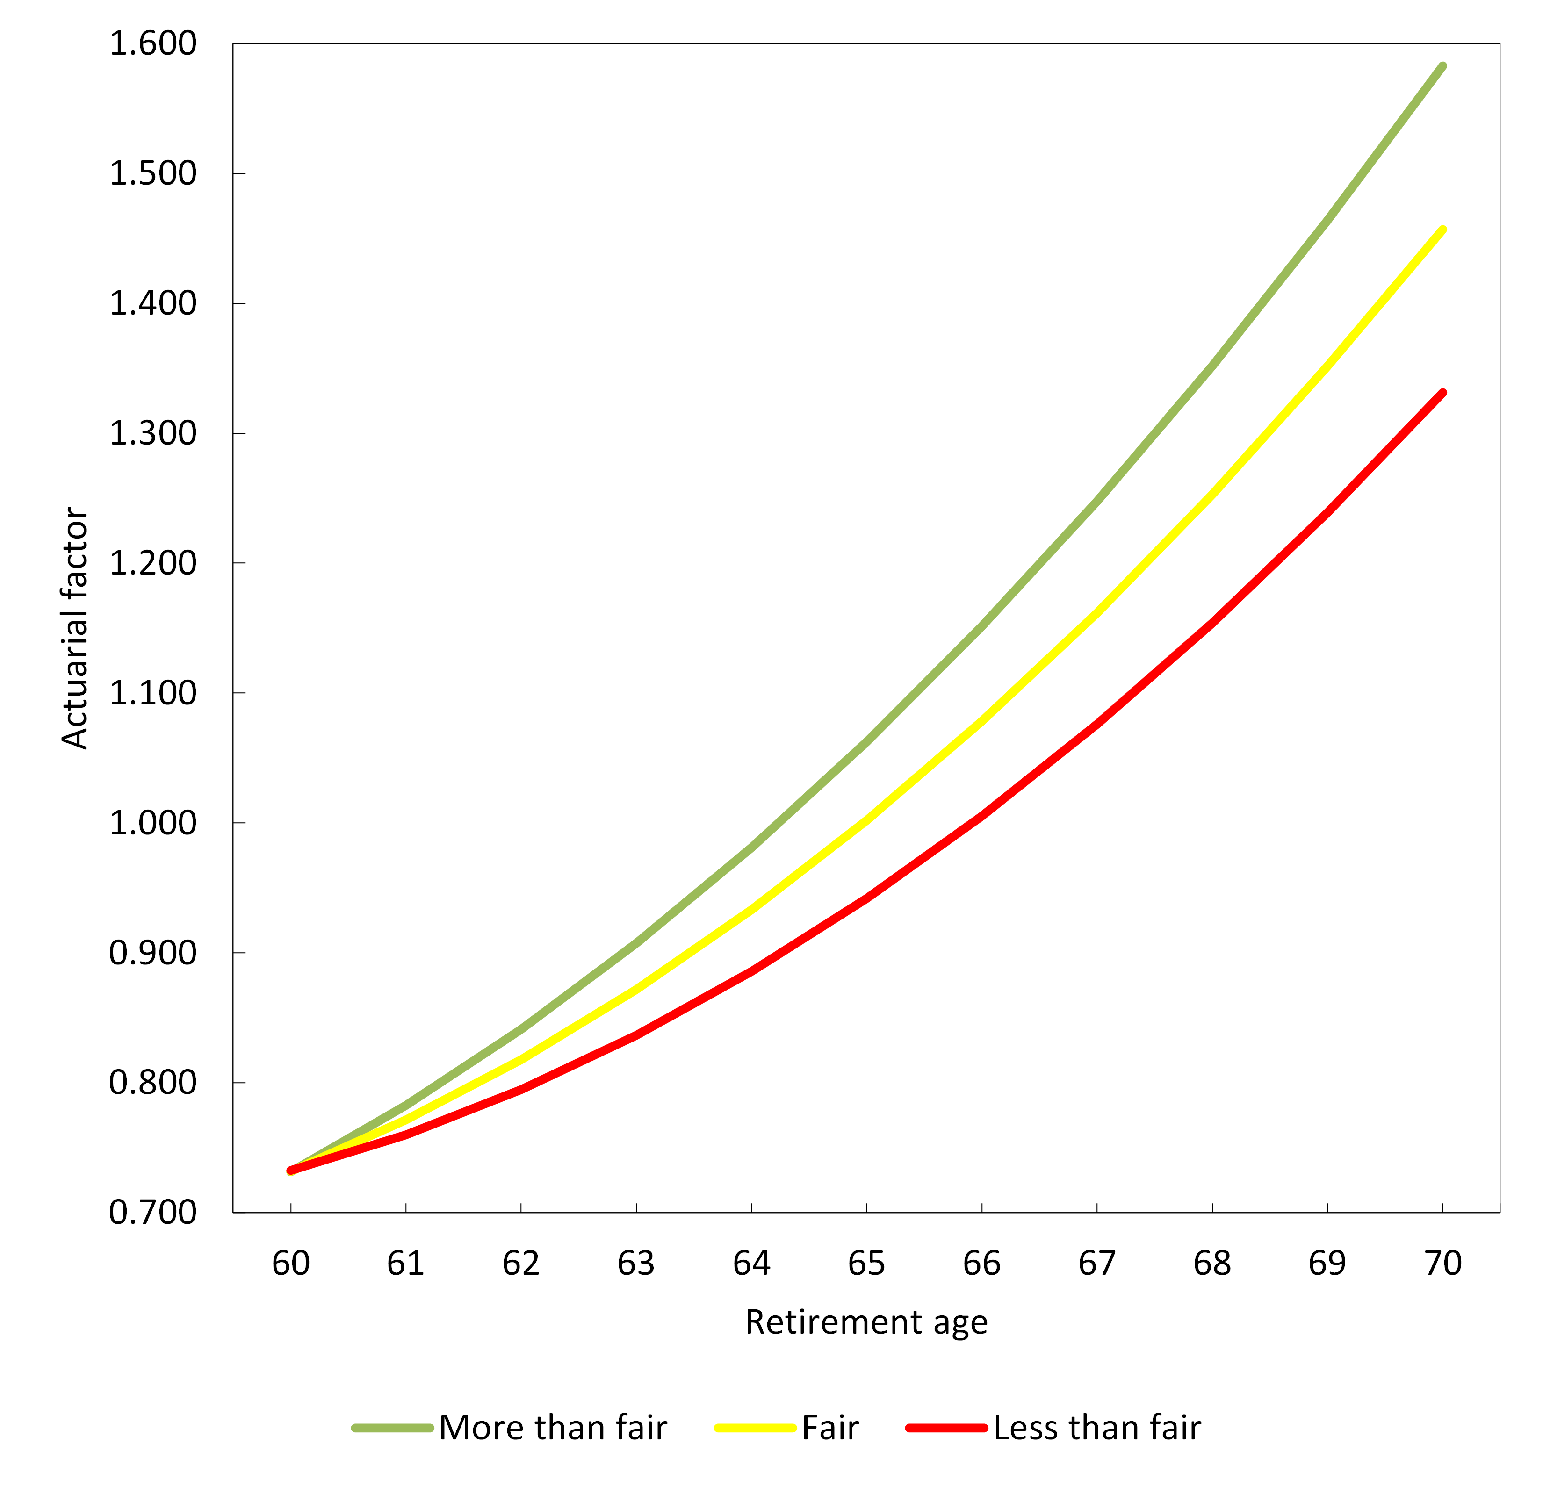

Figure 3: Actuarial factors that adjust pension rights due to claiming at different retirement ages.

We asked several follow-up questions if respondents chose the partial retirement scenario in a question on the choice between early, partial or late retirement.[15] First, they were also asked to choose only between the early and late (abrupt) retirement scenarios. Second, they were asked to choose among three scenarios of partial retirement with working hours 12, 20, and 28 hours per week during partial retirement (where higher numbers of weekly hours come with higher earnings and lower pensions during partial retirement, and higher pensions during full retirement). Third, respondents were asked to choose between two scenarios with partial retirement: in the first, hours worked per week is 20 during partial retirement for four years, while in the other, it is 20 for two years, and subsequently 10 for another two years (with adjusted earnings and pensions). All in all, each respondent got between three and eight stated choice questions, depending on how often the respondent chose partial retirement and therefore how many follow-up questions were asked.

1. **Data**

The survey was fielded in June 2017 in the LISS panel administered by Centerdata at Tilburg University. The panel is based on a random sample of households drawn from the population register, covering the Dutch non-institutionalized population. It consists of approximately 5,000 households comprising 8,000 individuals aged 16 and older who participate in monthly Internet surveys of about 15 to 30 minutes in total and are paid for each completed survey. Households that could not otherwise participate are provided with a computer and Internet connection. A longitudinal survey is fielded in the panel every year, covering a large variety of topics including work, education, income, housing, time use, political views, values and personality. Our survey was administered only to respondents aged 40 and older, generating 3,263 responses.

Table 2 presents the sample composition. More than half are 60 years of age or older. About one third have higher vocational education or a university degree. Most are married or living together with a partner, and own the house they live in. More than one third are working for an employer, and about one third are retired. About half of the sample earn a net monthly income of 1,000 to 3,000 euros.

The bottom part of the table concerns two variables related to preferences for leisure and early or late retirement, which will be used in the empirical analysis to proxy variation in preferences that is normally unobserved. The first is the answer to the survey question “To what extent do you agree with the statement “I would work even if the money is not needed on a scale from 1 (strongly disagree) to 7 (fully agree). The second is to construct a proxy for planned (for those who did not yet retire) or realized (for those who retired) retirement behavior. We asked respondents to construct the sequence that corresponds as much as possible to their actual behavior or their current plans. For each two years age category 55-56, ..., 67-68, 69-plus, we asked them to indicate their dominant labor market status, choosing among full-time work, part-time work, or (fully) retired. See Figure A2 for the exact question and Table A1 for the most commonly reported sequences in the Appendix. In the model we will use a dummy “early retirement” defined as 1 if for the age categories 55-56, ..., 61-62, the respondent chooses “retired” at least once; for 16.89% of the sample, this dummy has value 1.

Table 3 presents choice fractions for competing retirement scenarios in the stated choice questions. Respondents more often choose partial retirement than early or late retirement, demonstrating a preference for a smooth life-cycle profile of leisure and consumption. When the partial retirement option is omitted, a slight majority of those who first chose partial retirement now choose early rather than late retirement.

More people choose partial retirement if duration of partial retirement is five instead of four years. When the wage rate in partial retirement is 20% lower than before (and partial retirement also implies a change to a less demanding job), partial retirement becomes less attractive. Partial retirement is more attractive if weekly hours worked is 20 than if it is 12 or 28. Whether hours worked is reduced in one or two steps hardly makes a difference.

Table 2: Sample composition

|  |  |
| --- | --- |
| Attribute | Percent |
| Age |  |
| 40-49 years old | 19*.*52 |
| 50-59 years old | 24*.*81 |
| 60-69 years old | 32*.*26 |
| 70 years old or older | 23*.*41 |
| Gender |  |
| Male | 52*.*09 |
| Education |  |
| Has higher vocational or academic education | 34*.*98 |
| Marital status |  |
| Married or living with partner | 72*.*69 |
| Employment status |  |
| Working for an employer | 38*.*38 |
| Retired | 35*.*32 |
| Working self-employed | 5*.*91 |
| Unemployed | 3*.*40 |
| Fully or partially disabled | 4*.*95 |
| Homemaker | 8*.*04 |
| Other | *4.0*0 |
| Home ownership |  |
| Owner | 75*.*19 |
| Last monthly net labor income in euros |  |
| 0 | 5*.*06 |
| 1-1000 | 20*.*60 |
| 1001-2000 | 39*.*75 |
| 2001-3000 | 26*.*48 |
| 3001 or more | 8*.*11 |
| Would work even if money was not needed |  |
| Strongly disagree | 22*.*89 |
| Disagree | 21*.*06 |
| Somewhat disagree | 7*.*52 |
| Not agree, not disagree | 16*.*24 |
| Somewhat agree | 14*.*72 |
| Agree | 13*.*21 |
| Totally agree | 4*.*36 |
| Experienced or expect early retirement | 16*.*89 |

Notes: LISS panel; 3,233 individuals.

Table 3: Choice fractions for competing retirement scenarios

|  |  |
| --- | --- |
| Scenario | Percent |
| E | 28*.*74 |
| P | 40*.*42 |
| L | 30*.*84 |
|  |  |
| E | 50*.*78 |
| L | 49*.*22 |
|  |  |
| E: P is 4 years | 27*.*62 |
| P: P is 4 years | 39*.*59 |
| L: P is 4 years | 32*.*78 |
|  |  |
| E: P is 5 years | 29*.*68 |
| P: P is 5 years | 41*.*10 |
| L: P is 5 years | 29*.*22 |
|  |  |
| E: Wage rate in P is same as in full-time work | 27*.*62 |
| P: Wage rate in P is same as in full-time work | 42*.*72 |
| L: Wage rate in P is same as in full-time work | 29*.*66 |
|  |  |
| E: Wage rate in P is 20% lower than in full-time work | 29*.*85 |
| P: Wage rate in P is 20% lower than in full-time work | 38*.*16 |
| L: Wage rate in P is 20% lower than in full-time work | 31*.*99 |
|  |  |
| P: 12 hrs/wk | 29*.*94 |
| P: 20 hrs/wk | 41*.*43 |
| P: 28 hrs/wk | 28*.*63 |
|  |  |
| P: 20 hrs/wk for 4 years | 50*.*66 |
| P: 20 and 10 hrs/wk in 2 successive periods of 2 years each | 49*.*34 |

Note: E: Early retirement. P: Partial retirement. L: Late retirement. Choice fractions are for vignette questions asking to choose …

* among E, P, and L,
* between E and L,
* among E, P, and L when the duration of P is 4 and when it is 5 years,
* among E, P and L when the wage rate in P is same and when it is lower than in full-time work,
* among three P scenarios with different number of hours worked per week, and
* among two P scenarios where hours are reduced in one or two steps.

1. **Modeling preferences**

Our model is similar to that of Van Soest and Vonkova (2014). It is a structural model designed to use the stated choice questions to analyze the potential consequences of higher retirement age, pension incentives, and partial retirement for the labor supply decisions of older individuals. This differs from the reduced form models used in several studies based upon stated preference data (see Section 1), where the attributes of the scenarios directly enter the equations to be estimated. The structural approach has the advantage that policies with new attributes can also be analyzed, as long as these attributes only affect income and hours worked in any of the years after reaching 60.

Our model does not explicitly incorporate uncertainty about future health, unemployment, wage growth, or savings, in line with the scenarios in the choice questions. See Kantarcı et al. (2023) for full details of the model.

The respondents are asked to make choices based upon their own preferences. The model essentially specifies their preferences through a utility function. The choice a respondent makes in each case is the choice that maximizes utility.

The utility of each scenario is the sum of utility values over the respondent’s life after reaching age 60 (variation in the scenarios start at age 60). Utility at a given depends on hours worked (leisure) at that age and income at that age (pension income plus earnings). How much respondents value leisure (versus work) and income depends on age and other observed factors like health, gender, education level and family composition, but also on characteristics that are not observed in the data. Error terms are added to account for suboptimal choices.

The attributes of the scenarios presented in the vignette questions determine leisure and income at all ages (after 60). For example, a scenario with late abrupt retirement at age 70 will have much less leisure in the years between 65 and 70 than a scenario with abrupt retirement at age 65, but it will typically also imply higher income from age 65 until age 70 (since earnings from paid work are usually higher than pension income) as well as from age 70 onward (due to the additional pension rights accumulated from age 65 to age 70). If respondent A chooses abrupt retirement at age 70 rather than age 65, while respondent B does the opposite, this implies that respondent B gives higher value to additional leisure instead of income than respondent A. In other words, the choices that are made are informative about the nature of the utility function. Using the data on all the choices made by all the respondents then allows us to estimate the distribution of preferences (both the average utility function and the variation across respondents) in the population.

Once we have estimated the preferences, we can use the results to analyze what people would choose in any situation, as long as the choice scenarios are characterized by the same attributes of the vignettes – for every choice scenario that can be chosen, it has to be clear how many hours of paid work is done and what it the total income at every age after age 60. That is, we can use the estimated model to simulate the effects of potential new policies with new implications for income and leisure over the life cycle. We will focus on policies related to partial retirement. As our benchmark, we first simulate the choice probabilities for early, late and partial retirement scenarios (of the same type in Figure 2) at various retirement ages. We then study how these choice probabilities change under alternative policies. For example, what happens if partial retirement is made more attractive by a policy that makes partial retirement more attractive, such as the current “Vitaliteitsregeling” of Dutch universities (the possibility to work 80% or 60% of the time for 85% or 70% salary and with full pension accruals). Such alternative policies, irrespective of whether they already exist or not or whether they are in the vignette questions or not, change the attributes of the scenarios and therefore change the choice probabilities, given the population’s preferences. With the estimation results, we will be able to predict how many people would change their choice in case such a policy would be introduced and, for example, we can predict to what extent making partial retirement more attractive will raise the chances to choose partial retirement, and if so, to what extent this will make fewer people retire early or will make fewer people retire late.

1. **Results**

A table with the estimates of all the parameters of the structural model is provided in Kantarcı et al. (2023). These parameters are used for the policy simulations below but are often hard to interpret directly. The only thing that is directly interpretable are the signs of the parameters on the “taste shifters”. These parameters indicate how respondent characteristics are related to a stronger or weaker preference for leisure compared to income. These parameter signs and their significance levels are presented in Table 4. Most of these are significant, implying substantial observed heterogeneity with respect to leisure preferences. (In addition, the estimates imply that there is also substantial variation in preferences that is not captured by observed respondent characteristics.)

Table 4: Taste shifters

|  |  |  |  |
| --- | --- | --- | --- |
| Respondent characteristic | Sign of the effect on marginal utility of leisure | | |
|  |  |  |  |
| Age of the respondent | − | ** |  |
| Dummy male respondent | − | ** |  |
| Dummy respondent has high education | − | * |  |
| Dummy household with no children | + |  |  |
| Dummy respondent lives with partner | + | ** |  |
| Dummy respondent is a Homeowner | + | ** |  |
| Dummy respondent had a health problem in the last six months | + | ** |  |
| Dummy respondent would work even if money was not needed | − | ** |  |
| Dummy respondent experienced or expects early retirement | + | ** |  |
| Running age (in each year) | + | ** |  |

Notes:

A positive sign implies a larger preference for early retirement.

* = significant at 5% level; **: significant at 1% level

The significant negative estimate of age at the time of the survey suggests that older respondents attach less utility to leisure. This could be a cohort effect but may also mean that younger workers overestimate their taste for leisure at an older age, or that older individuals more often realize the risk of not being able to meet their consumption needs in retirement and hence see the need to work longer. Men attach more value to income and less to leisure than women do, reflecting the fact that on average, Dutch men work more hours than women do. Higher educated respondents value leisure less than lower educated respondents, possibly since they have jobs that are more attractive (and spending time on them gives less disutility). Respondents with a partner attach more value to leisure than singles, possibly due to a desire for joint leisure activities or the need for home production. Homeowners derive more utility from leisure, possibly because they can better afford it, attaching less value to additional income. Those who had a health problem during the six months prior to the survey also attach more value to leisure, probably since they also expect health issues in the future, implying an increasing disutility of working longer.

The variable “would work even if money was not needed” can be interpreted as a proxy for a low disutility of work, or even a positive marginal utility of working at least a few hours, keeping income and other variables constant.[16] In line with what one would expect, individuals with a low disutility of work tend to prefer later retirement and have a lower marginal utility of leisure (keeping other variables constant). Finally, those who expect to take early retirement (individuals who have not yet reached an age at which they can retire) or experienced early retirement (if old enough to be able to take early retirement) choose scenarios with more leisure, implying they have a higher marginal utility of leisure. This shows there is a significant positive relation between revealed preferences (planned retirement or actual retirement) and the stated choices in our stated preference experiment. It indicates that our stated choice questions have predictive value for actual choices, confirming the usefulness and relevance of the stated preference questions (cf. Michaud et al., 2020). Of course, the correlation is not perfect, since in real life, many other factors that are not captured in our experiment may play a role (job characteristics and employer attitudes, employer-imposed restrictions on part-time work, lack of information on pension entitlements, etc.) and the positive correlation does not prove that the answers to the stated choice questions always reflect the same underlying preferences that drive actual decisions.

The significant positive estimate of “running age” – age in the future period for which the contribution to lifetime is calculated - implies that respondents attach increasing utility to leisure as they age, probably because they expect that health deterioration will increase the disutility of working. It could also be that a social norm or the expected labor market position of the partner or their reference group makes working at an older age less and less attractive.

1. **Policy simulations**

We use the estimated model to simulate the effects of several hypothetical as well as some realistic policy changes on retirement decisions, focusing on partial retirement. As our benchmark, we first simulate the choice probabilities for early, late and partial retirement scenarios (of the same type in Figure 2) at various retirement ages. We then study how choice probabilities change if the statutory retirement age is increased (Section 7.1), the characteristics of partial retirement change (Section 7.2), the financial incentives for retiring earlier or later change (Section 7.3). Section 7.4 compares settings with and without partial retirement options, giving insight in whether partial retirement stimulates total labor supply of older workers or not. These simulations give insight in the sensitivity of the choices for the main attributes of the scenarios, but do not necessarily reflect actual or planned policy changes in the Netherlands. The final simulations discussed in Section 7.5, reflect the actual policy embodied in the current “Vitaliteitspact” as implemented in the collective bargaining agreement of Dutch universities (see Section 2).

The retirement scenarios considered in the simulations are based on the original experimental design described in Section 3, but replacement rates are adapted to the alternative retirement ages (to account for the total number of years of pension accrual and actuarial adjustments to pensions at those ages). Simulated choice probabilities are averaged over the complete sample and account for observed and unobserved heterogeneity as well as optimization errors.

**7.1 Increasing the statutory retirement age**

*Increasing the statutory retirement age reduces interest in late abrupt retirement and increases interest in early retirement, but hardly affects the (substantial) interest in partial retirement.*

Figure 4 shows simulated average probabilities of choosing early, partial and late retirement as a function of the age of abrupt retirement or the start of partial retirement: the first point on the left is a choice between abrupt (early) retirement at age 60 (with a low pension), partial retirement from age 60 to age 64 (or 63 if duration of partial retirement is 4 years) and full retirement thereafter, or abrupt (late) retirement at age 65 (or 64 if duration of partial retirement is 4 years). Moving along the horizontal axis gives the same probabilities if all these ages increase by 1, 2, ... 6 years. Hence, on the right-hand side, the choice is among abrupt early retirement at age 66, partial retirement from age 66 until age 70 (or 69), or abrupt retirement at age 71; the three choice probabilities always add up to 100%. When the statutory retirement age increases, the probability of early retirement increases and the probability of late retirement falls. For example, increasing the retirement age from 61 to 63 increases the probability of early retirement from 20 to 30%. The probability of partial retirement, however, is always between 32 and 35%, demonstrating the potential of partial retirement schemes, particularly if full-time working becomes unattractive due to an increase of the statutory retirement age. Note that even if the age of partial or full retirement is raised to 66, about half of the respondents would still want to work after that age. This result is in line with Ameriks et al. (2020), who find a substantial interest in the US in working longer if jobs were flexible.

The strong interest in partial retirement suggests that there is a substantial group of individuals who in principle would prefer a smooth life-cycle profile of leisure, gradually reducing paid work hours and increasing hours spent on other activities (“leisure”, in our model) instead of abruptly changing from full-time paid work to full retirement. The probabilities to choose partial retirement are much larger than the fractions of workers who actually choose partial retirement (Kok et al., 2018), pointing at other factors that hamper the combination of part-time work and partial retirement in practice. Many such factors can be thought of that are not incorporated in our vignettes: restrictions imposed by the employer, health issues and (partial) disability, the role of the partner, etc.

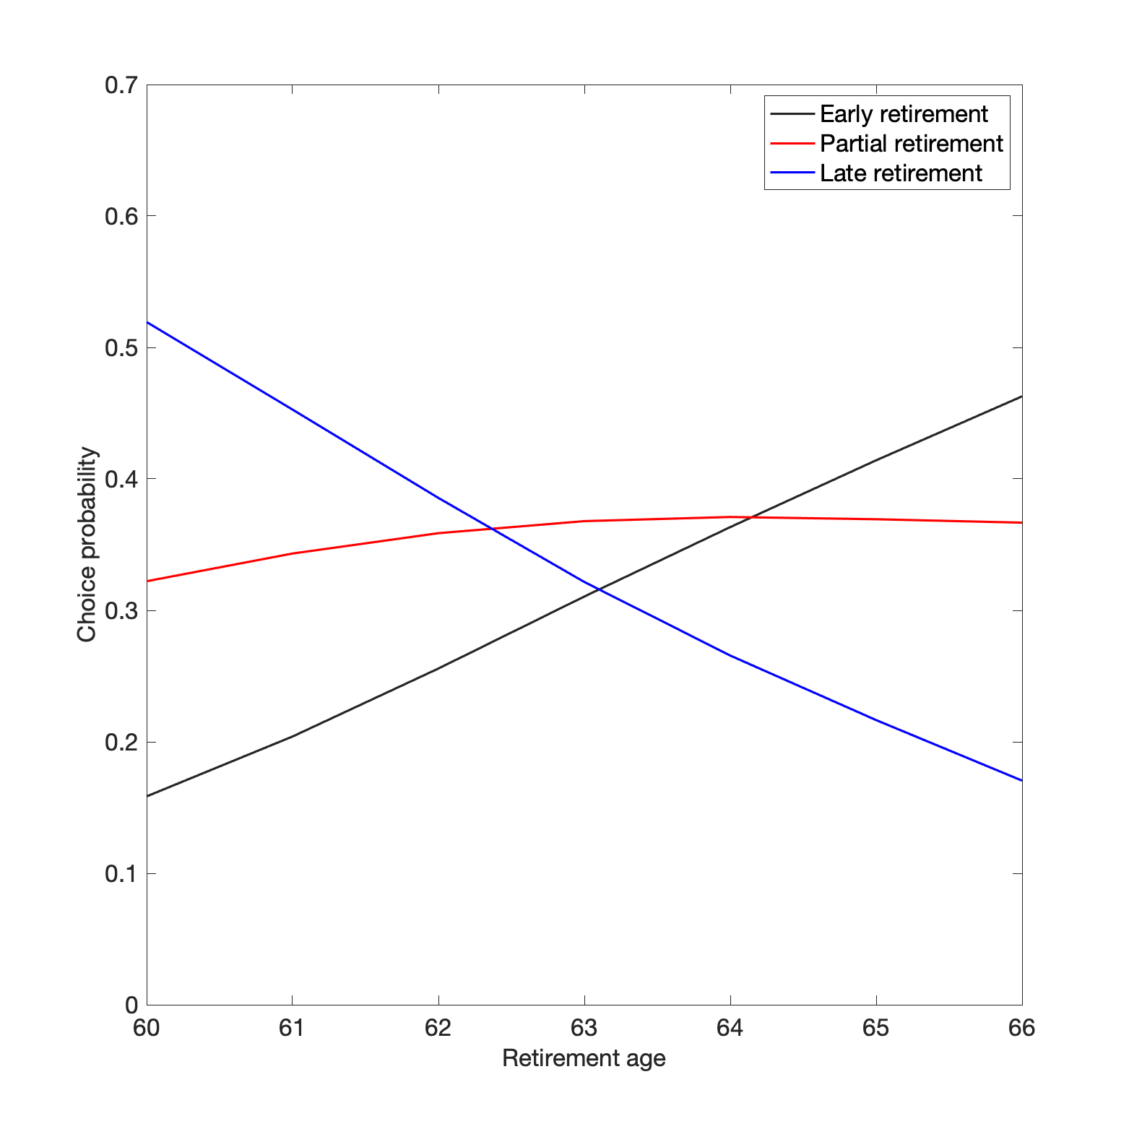

Figure 4: Probabilities of choosing among early, partial and late retirement at given ages. Note: the horizontal axis is the age at which someone switches from full-time to work to partial or full retirement

**7.2 Changing the characteristics of the partial retirement plan**

*With an increasing statutory retirement age, the interest in partial retirement is insensitive for whether partial retirement is for four or five years or comes in one or two steps, but it would increase a lot if partial retirement would imply fewer hours of work, 12 instead of 20 per week. Partial retirement becomes much less popular if it comes with a reduced wage rate.*

Figure 5 compares simulated choice probabilities when duration of partial retirement is either four years or five years with actuarially adjusted pension levels; accordingly, in the late abrupt retirement option, retirement starts either four or five years later than in the early retirement option. At earlier retirement ages, a longer partial retirement period makes partial retirement more attractive, at the cost of late retirement. The probability to choose early retirement is rather low irrespective of the partial retirement duration. This is different at later retirement ages – here the duration of partial retirement hardly matters for how many people choose partial retirement. With the longer partial retirement duration, more individuals choose early retirement rather than partial retirement if the retirement age increases (they do not want to work for an extra year, not even part-time), but at the same time many individuals switch from late retirement to partial retirement – they prefer an extra year part-time to an extra year full-time.

Figure 5: Probabilities of choosing among early, partial and late retirement at given ages, distinguishing between partial retirement for 5 and for 4 years.

Figure 6 shows the choice probabilities for three different numbers of hours worked during partial retirement: 12, 20 or 28 hours. The differences in the choice probabilities are notable. At a low retirement age, partial retirement with 28 hours of work per week is an often-chosen alternative for full retirement. At higher retirement ages, the situation reverses and working 28 hours is often not attractive, like full time work. At a high retirement age, partial retirement with a small part-time job is often chosen as a good alternative for early retirement.

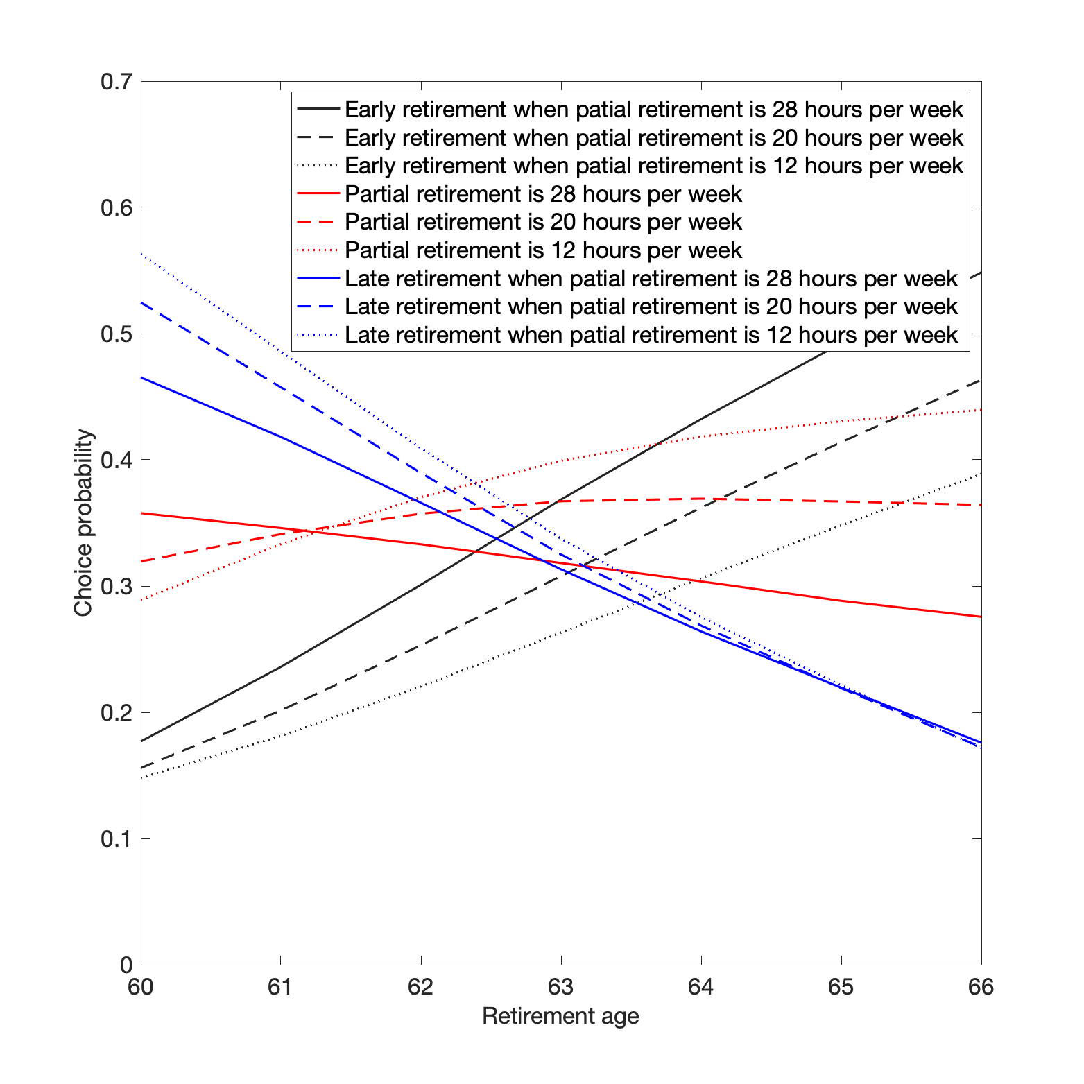

Figure 6: Probabilities of choosing among early, partial and late retirement at given ages, distinguishing among partial retirement with 28, 20 and 12 hours per week.

Figure 7 presents the choice probabilities when the number of weekly hours worked is reduced in one step (from 40 to 20 hours per week) or in two steps (first from 40 to 20 hours, after two years from 20 to 10 hours per week). In the latter case total labor supplied is smaller due to working fewer hours during the second half of partial retirement. At earlier retirement ages, two steps are less attractive than partial retirement in one step. For the higher retirement ages, there is hardly any difference between the probabilities for the one and two steps partial retirement plans.

Figure 7: Probabilities of choosing among early, partial and late retirement at given ages, distinguishing between partial retirement in 1 and 2 steps.

Existing studies provide evidence that older workers who take a part-time job before they fully retire often work at a reduced hourly wage, due to a part-time wage penalty or to switching to a less demanding job (Aaronson and French 2004; Rogerson and Wallenius 2009). Figure 8 shows simulated choice probabilities when hourly wages in partial retirement are the same as when working full-time prior to partial retirement, and when they are 20% lower or higher. The partial retirement option clearly becomes more attractive for a higher wage during partial retirement, irrespective of the retirement age. A reduction in the hourly wage mainly induces many individuals to choose to continue working full-time rather. On the other hand, an increase in the hourly wage rate (e.g., by subsidizing gradual retirement) induces many people who otherwise would have stopped working early to take partial retirement.

Figure 8: Probabilities of choosing among early, partial and late retirement at given ages, when the wage rate during partial retirement changes.

**7.3 Financial incentives**

*The interest in partial retirement is not sensitive for the overall generosity of pensions, but does increase with the rewards for working longer (the accruals)*

Figure 9 shows simulated choice probabilities when pension accruals are based on an accrual rate of 2.05% (the benchmark), 1.85%, or 2.25%, giving lower and higher pension levels than in our experimental design, see Section 3. The alternative accrual rates imply replacement rates that are 10 pp lower or higher than the replacement rates implied by the benchmark accrual rate of 2.05% (Table 1). The effects we find are in line with the notion that leisure is a normal good: a higher replacement rate implies more early retirement and less late retirement. The probability of choosing partial retirement does not change much. The effects are sizable compared to the existing literature. For example, for the US, Van der Klaauw and Wolpin (2008) found that a 25% reduction in Social Security benefits reduces labor participation of both husbands and wives aged 51-61 to a limited extent but increases labor participation of individuals aged 62-69. Delavande and Rohwedder (2017) found that individuals would expect to work longer and reduce spending if their Social Security benefits were cut by 30%. For Ukraine, Danzer (2013) found that a 10% rise in the minimum pension level increases the probability of retiring by 1.2% for women and 1.9% for men. In their stated preferences study for the Netherlands, Van Soest and Vonkova (2014): also found a substantial income effect: reducing replacement rates by 10 percentage points would increase the average retirement age by 3.24 months.

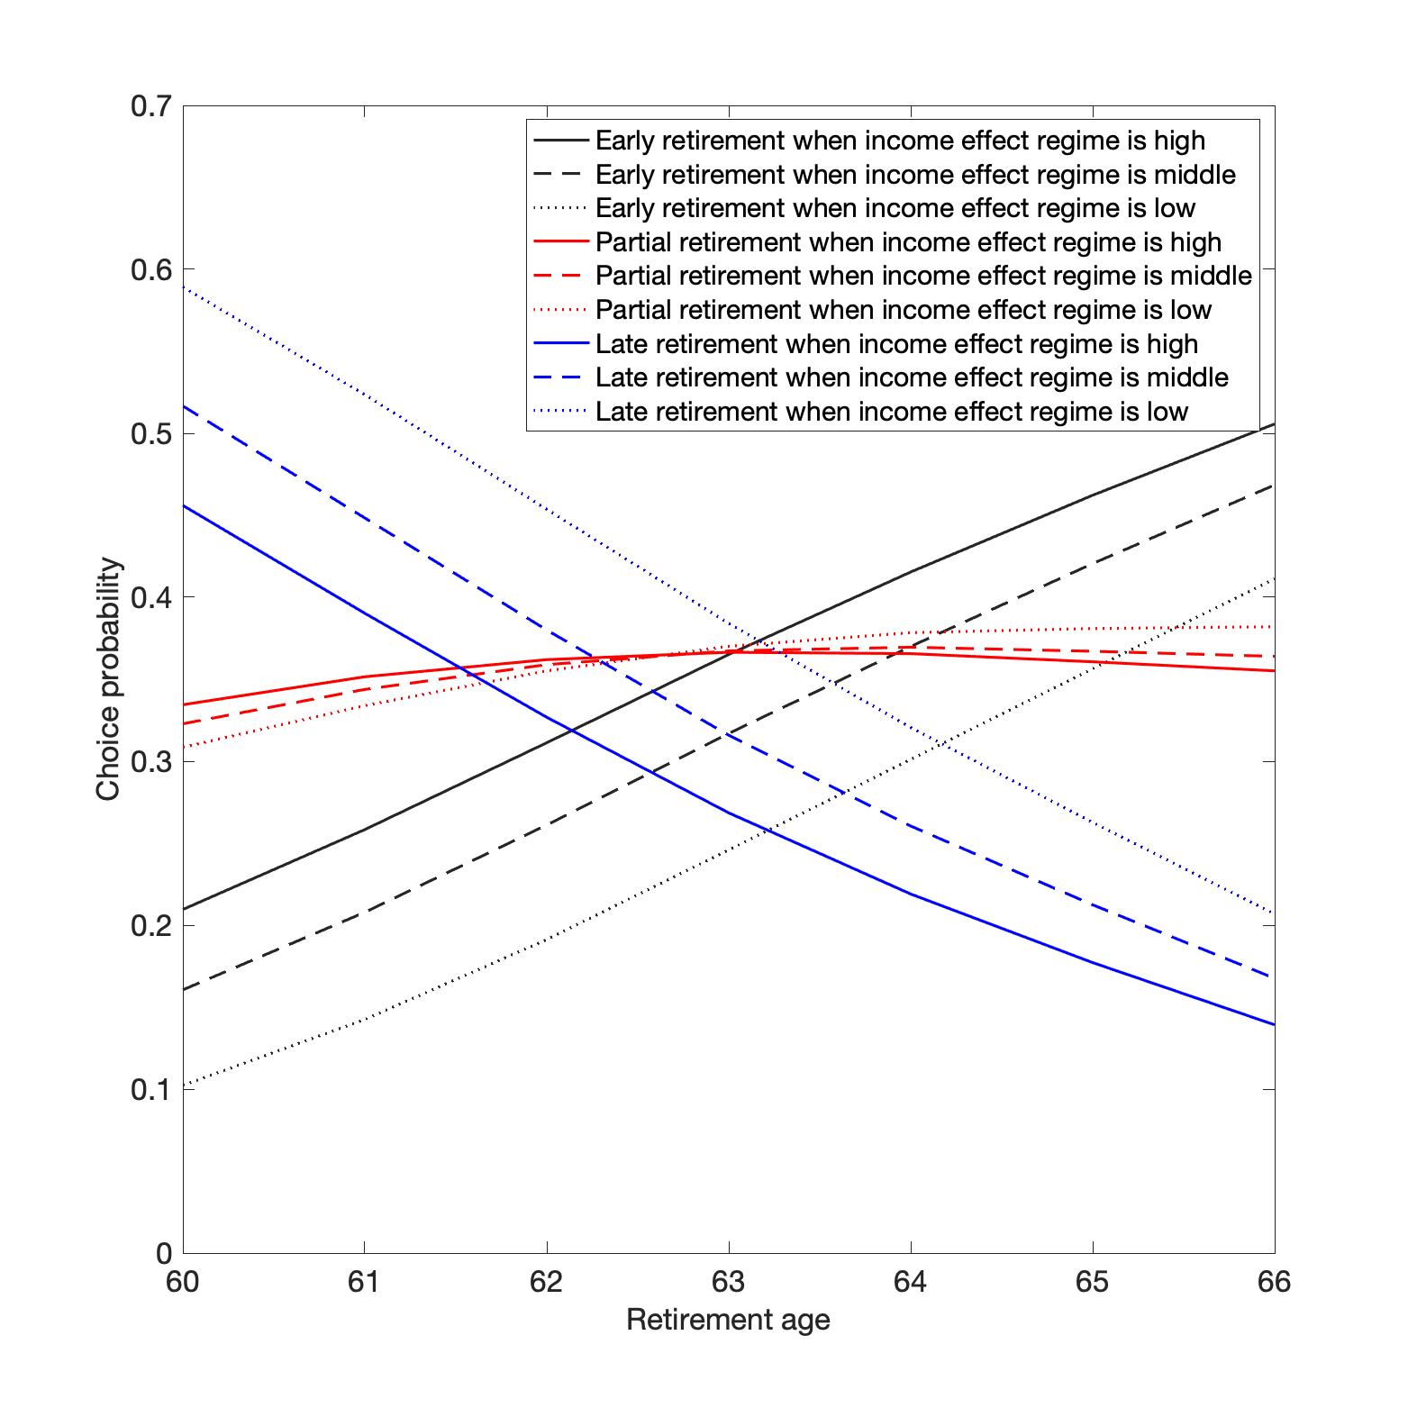

Figure 9: Probabilities of choosing among early, partial and late retirement at given ages, when pension benefit levels change irrespective of the retirement age.

Figure 10 shows what happens if rewards for later retirement are based on higher or lower actuarial factors than those used by the largest Dutch pension fund, using the factors shown in Figure 3. Higher rewards for later retirement substantially reduce the probability to choose early retirement. This is in line with earlier studies. For example, Van Soest and Vonkova (2014) found that the average retirement age would fall by 9.72 months if the rewards for retiring later would be halved. Particularly if the statutory retirement age is high, it increases the probability of partial retirement more than the probability of late (abrupt) retirement. Apparently, the higher rewards are not enough to make people work full-time until high age, but they do convince people to continue working part-time. To the best of our knowledge this is the first evidence on the price effect of pensions on the partial retirement decision.

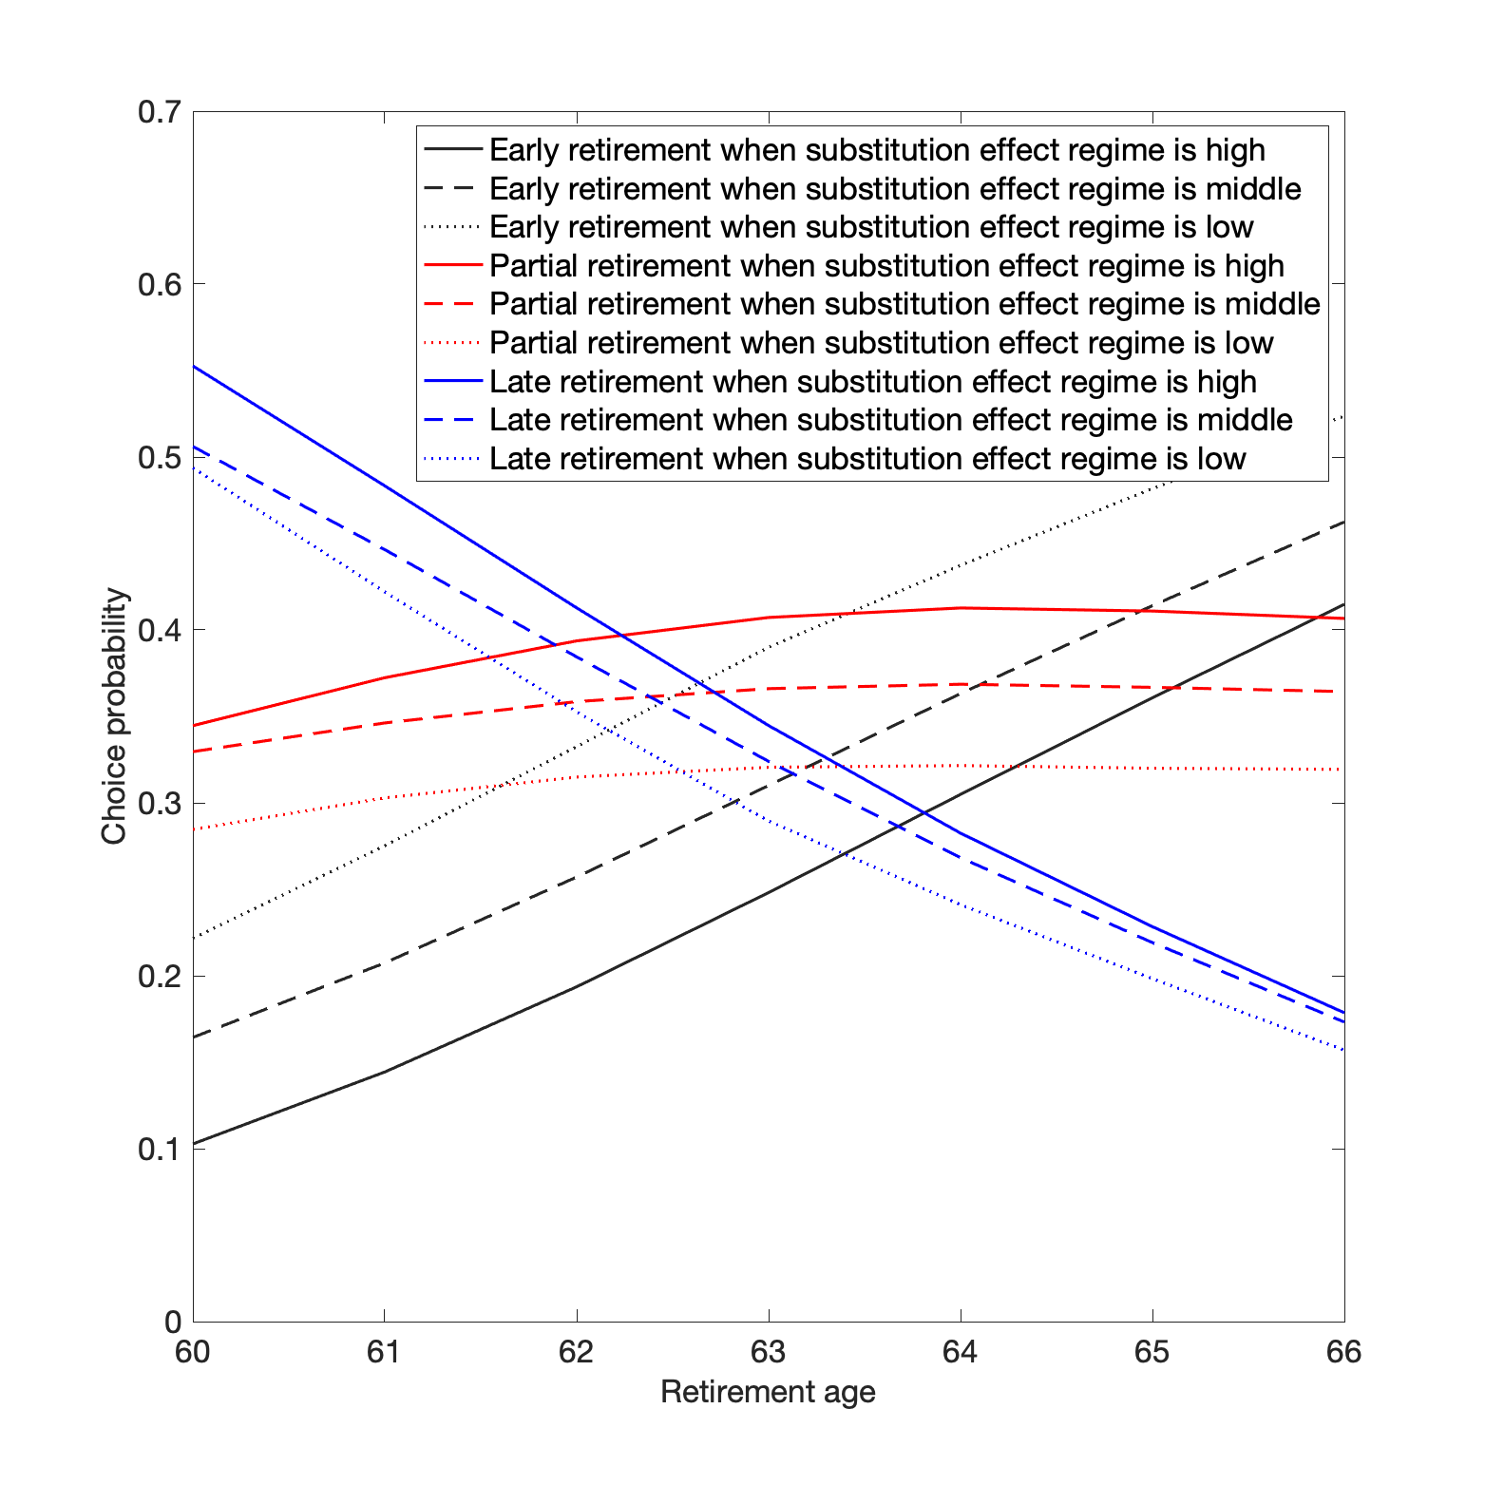

Figure 10: Probabilities of choosing among early, partial and late retirement at given ages, when the pension benefit accrual induced by delaying retirement changes.

**7.4 The added value of partial retirement**

*Facilitating partial retirement not only increases labor force participation but also has the potential to increase total labor supply.*

Figure 11 shows how choice probabilities for early and late retirement change when partial retirement is omitted. Choice probabilities for early and late retirement increase at every retirement age, and the increase is always larger for early than for late retirement. Since in this simulation partial retirement always means working half-time, this suggests that introducing the option of partial retirement has a positive impact on total labor supply. This positive effect is larger at later statutory retirement. This is plausible: since the propensity of early retirement increases at later statutory retirement ages, partial retirement more often becomes an attractive alternative to early retirement.

This result is in line with Ameriks et al. (2020) who find that older individuals in the US would work longer if they had opportunities to work in jobs that allow them to choose hours worked per week or weeks worked per year. For Germany, Huber et al. (2016), Berg et al. (2020), and Haan and Tolan (2019) also conclude that encouraging partial retirement can lead to positive labor supply effects. They are also in line with Been et al. (2018) who in their reduced form analysis find that introducing partial retirement could increase the average retirement age by 0.9 months.

The findings differ, however, from several other studies: Börsch-Supan et al. (2018) exploited cross-country variation in pension systems with respect to whether they adopted partial retirement schemes, to explain differences in annual labor force participation and work hours between these countries. They found a negative effect of more flexibility in the choice of working hours on total hours worked. They also differ from the conclusion of Elsayed et al. (2018) and Montizaan (2017) that in the Netherlands, partial retirement arrangements make people retire completely one year later, on average, but might reduce total labor supply, since many individuals who would otherwise keep working full-time will switch to partial retirement. The reason for the different conclusions may be that the effect on total labor supply depends on the context, e.g. the nature of early retirement schemes.

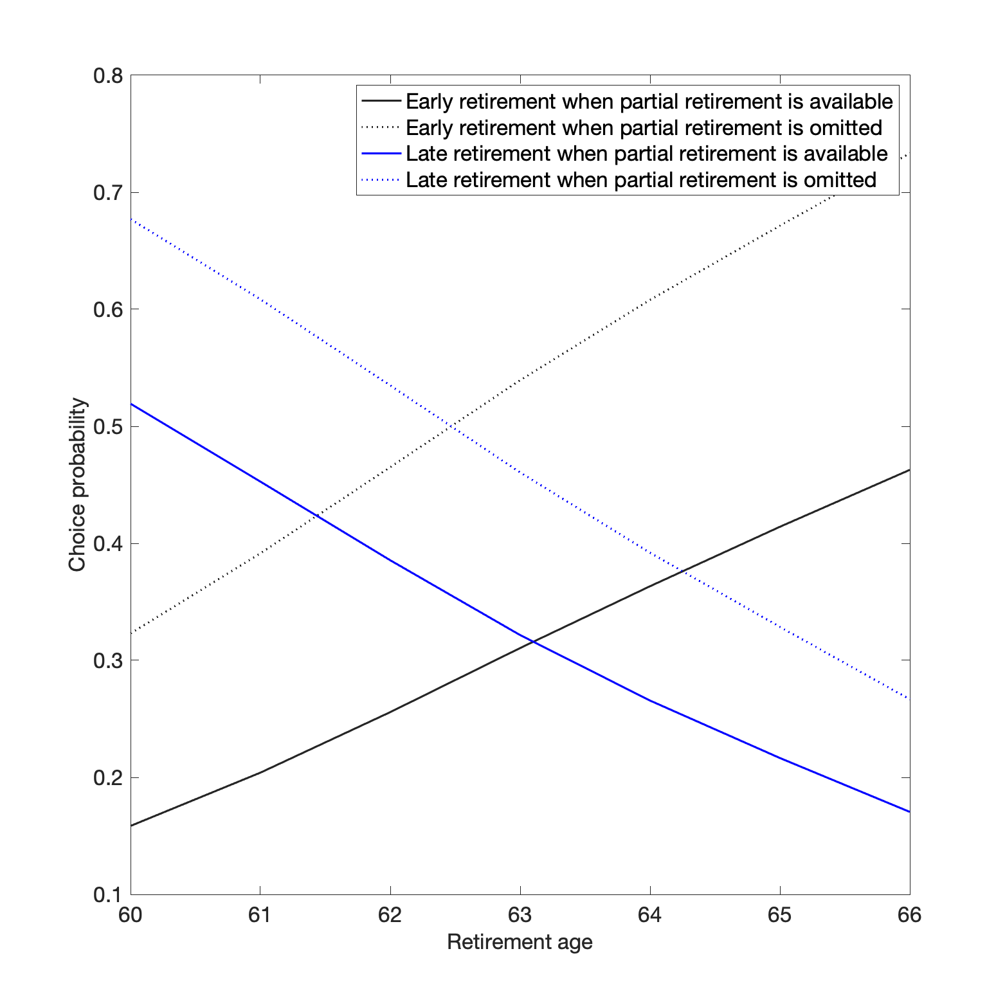

Figure 11: The effect of introducing partial retirement on total labor supply.

**7.5 Subsidizing partial retirement**

*Subsidizing gradual retirement arrangements (“Het Generatiepact”) can make gradual retirement substantially more attractive and has a positive effect on total labor supply.*

Until now, we essentially assumed that partial retirement was rewarded in an actuarially neutral manner. Individuals have maximum flexibility and pay a fair price for retiring partially. Recently, however, in response to the elimination of generous early retirement arrangements and the increase of the state pension eligibility age which hampered many workers to retire earlier even in case of health problems, labor unions and employers introduced new subsidized partial retirement schemes (“Generation pact”) in collective labor agreements; see, e.g., Rutten et al. (2022) for details on how this is implemented in parts of the public sector. At any age from, for example, five years before the state pension eligibility age until this age, these schemes allow a worker to reduce work hours with a less than proportional decrease in salary and no reduction in pension accruals. These schemes do not allow people to claim pension rights during partial retirement. Sector agreements differ in how much weekly hours can be reduced and how much they subsidize the salary; they typically offer multiple options. In this paper, we focus on one specific example - the collective labor agreement of Dutch universities. It states that employees can work 80% of their former hours and earn 85% of their former wage, or they can work 60% of the former hours and earn 70% of the former wage. In both variants employees accrue pensions rights over 100% of their former wage. They can also switch from the first to the second variant after one year.

Figures 12 to 14 present the choice probabilities for three scenarios using this arrangement, comparing them to the benchmark of the standard actuarially neutral partial pension arrangement but without partial pension – the difference therefore exclusively shows the effect of the subsidy. In Figure 12, the subsidized partial retirement option means the employee works 80% of former hours and earns 85% of the former wage, while in the benchmark partial retirement option she works 80% of former hours and earns 80% of the former wage. Moreover, in the subsidized partial retirement option, pension rights accrue over 100% of the former wage, while in the benchmark partial retirement option, they accrue over 80% of former wage. We consider decisions at each age from 62 to 65, each lasting until age 67 (the state pension eligibility age in 2024). Therefore, duration of partial retirement depends on the age partial retirement starts. The other two figures make similar comparisons for the other variants (work 80% in the first year and 60% in later years until the statutory age, or immediately work 60% in all partial retirement years). Table 5 provides the details.

Table 5: Competing subsidized and default partial retirement scenarios

|  |  |  |  |
| --- | --- | --- | --- |
| Simulation exercise | Steps of partial retirement | Generation pact regime[17] | Standard ABP regime |
| 1 | 1st and only step | 0.80 work | 0.80 work |
|  |  | 0.85 wage | 0.80 wage |
|  |  | 1.00 pension accrual | 0.80 pension accrual |
| 2 | 1st step of 2 steps | 0.80 work | 0.80 work |
|  |  | 0.85 wage | 0.80 wage |
|  |  | 1.00 pension accrual | 0.80 pension accrual |
|  | 2nd step of 2 steps | 0.60 work | 0.60 work |
|  |  | 0.70 wage | 0.60 wage |
|  |  | 1.00 pension accrual | 0.60 pension accrual |
| 3 | 1st and only step | 0.60 work | 0.60 work |
|  |  | 0.70 wage | 0.60 wage |
|  |  | 1.00 pension accrual | 0.60 pension accrual |

Notes: To make the scenarios comparable except for the subsidy, there is also no partial pension during partial retirement in the non-subsidized case.

The figures show that the subsidies make partial retirement substantially more attractive, particularly if offered at an early stage so that individuals benefit from the subsidy for a longer period (five years). The two-step variant gives the largest effect of the subsidy: the probability to choose partial retirement at age 62 would increase by 10 pp. The reductions in the probabilities of early and late retirement are almost the same. Since in this set up partial retirement implies working more than half-time, the effect on total labor supply would be positive. This suggests that wage compensation is an important determinant of the preference for partial retirement. This is in line with Figure 8 where simulated decisions are shown to be sensitive to hourly wages during partial retirement.

Figure 12: Generation pact: 80% of hours worked, 85% of gross earnings, 100% pension accrual.

Figure 13: Generation pact: 80% of hours worked, 85% of gross earnings, 100% pension accrual in the first year; 60% of hours worked, 70% of gross earnings, 100% pension accrual in the remaining years of partial retirement.

Figure 14: Generation pact: 60% of hours worked, 70% of gross earnings, 100% pension accrual.

1. **Conclusion**

Partial retirement seems an attractive way to gradually withdraw from the labor market, avoiding the sudden change in time use and activities of abruptly switching from full-time work to no paid work at all. This is in line with standard models of labor supply in which individuals prefer to smooth leisure and consumption over the life cycle. In practice, however, partial retirement is less common than one might expect on the basis of preferences alone, due to demand side restrictions or institutional constraints. In this paper, we have followed several recent papers by studying partial retirement using stated choice survey questions, aiming at an analysis of labor supply preferences only, purged from the restrictions that someone’s actual labour market position may impose. Our questions provide a more detailed picture of partial retirement than existing studies by considering several properties of the design of the partial retirement option, such as the starting and ending age, the hourly wage rate, the number of hours worked, and whether the transition to full retirement involves multiple steps or not.

We use vignette questions asking respondents to make choices based upon their own preferences but for hypothetical individuals, making it possible to ask respondents to make choices that are not realistic in their own situation. We account for the standard actuarial rules of pension systems, making the tradeoffs between income and leisure as realistic as possible.

The labor supply preferences that we estimate correlate in plausible ways with peoples’ actual or predicted retirement plans and with a subjective question on whether they value work just for money or for its intrinsic value. This lends credibility to our stated choice data and can be seen as a validation exercise. We randomly vary retirement plan characteristics in several questions across respondents, generating rich variation in choice sets and stated choices. We exploit this variation to obtain accurate model estimates and conduct credible counterfactual policy simulations.

We find substantial interest in partial retirement scenarios, with more than one third of the respondents choosing partial retirement rather than actuarially fair early or late abrupt retirement trajectories. The probability to choose partial retirement hardly varies with the statutory retirement age. The fact that stated interest in partial retirement is stronger than the actual prevalence of partial retirement suggests that actual partial retirement is often hampered by demand side restrictions.

Using the stated choice data, we estimate a stylized model that makes the trade-offs between leisure and income over the life cycle as of age 60 explicit. Responses to pension incentives, for both abrupt and partial retirement, are sizable compared to those found in earlier studies, considering that the sizes of the incentives we consider are much smaller. This is important because small pension incentives are much more within the reach of policy makers who have to carefully consider pension interventions.

We disentangle accrual and wealth effects of pensions at both the intensive and extensive margins at various retirement ages. We find that the partial retirement decision is much less sensitive to wealth effects than the decisions for early or late abrupt retirement. On the other hand, the decision to take partial retirement is sensitive to pension accruals. More importantly, the partial retirement decision strongly depends on the specific financial incentives for retiring partially. Interest in partial retirement would fall substantially if partial retirement came with a substantially lower wage (and a less challenging job). Finally, if individuals do not have the partial retirement option, early abrupt retirement more often becomes the best alternative than late retirement, demonstrating the potential of partial retirement as a policy instrument to stimulate older individuals remain in the labor force.

Our results should be interpreted cautiously with respect to actual retirement behaviour. Ideally, policy reforms regarding flexibility in retirement would be ex post evaluated using policy changes and quasi-experimental research methods. In absence of such reforms in the Netherlands, however, we evaluated partial retirement policies ex ante using hypothetical retirement scenarios evaluated by survey respondents and simulation. Respondents might not act as they state. We attempted to mitigate this concern by validating stated preferences with actual retirement behavior by respondents.

Furthermore, our stated preference survey was conducted in 2017, at a time when the generous early retirement arrangements of the 1990s were almost completely phased out. Moreover, at that time individuals in paid employment were subjected to an increasingly higher statutory retirement age. As a consequence, the actual average retirement age was increasing, probably also inducing a change in the social norms for what constitutes a good retirement age. This trend implies that the retirement ages considered in our survey (61, 63, and 65) currently may no longer have the same meaning as in 2017. However, a prior study that investigated people’s preferences for partial retirement in the Netherlands suggests that employees had very similar preferences for partial retirement in 2004, far prior to the disappearance of generous early retirement and the increase in the statutory retirement age (Van Soest et al., 2006). We therefore expect the strong interest in partial retirement to be persistent or even increase with the increasing retirement age, as Figure 1 suggests.

**8. Policy discussion**

In the last decades, generous early retirement arrangements were phased out and the statutory retirement age making individuals eligible for a state pension has been raised substantially. As a result, many workers are forced to work longer, even if full-time work is hampered by health issues or unattractive for other reasons. One way to address this issue is to stimulate partial retirement: A gradual withdraw from the labor market, combined with a partial pension to supplement part-time earnings. In this paper, we have used stated preference data and a structural life cycle model to investigate the potential interest of workers in several different implementations of partial retirement arrangements.

Our policy simulations showed that preferences for partial retirement plans are responsive to financial incentives. In particular, rewarding later retirement with higher pension accruals makes partial retirement more attractive than early retirement. At the same time, facilitating partial retirement plans can generate both positive and negative labor supply effects as discussed here and widely in the existing literature. For stimulating labor supply through partial retirement and financial incentives, it is therefore important to carefully design the financial incentives for partial retirement plans so that partial retirement becomes a more attractive alternative to early retirement than late retirement.

To date, partial retirement arrangements have typically been laid down in second-pillar pension schemes and they are being increasingly introduced in collective labor agreements. A possibility is to consider flexibility also in the first-pillar pensions. In many countries it is possible to take up first-pillar pension benefits before the normal retirement age at an actuarial discount. Such early take-up could facilitate partial retirement and even stimulate labor supply. Until now, Dutch policymakers have been hesitant about making the claiming of first-pillar pensions (AOW) more flexible. There are no options to claim AOW-benefits prior to the statutory retirement age. In 2015, the Dutch cabinet even formally cancelled any plans for a flexible AOW in the near future.[18] This implies that the only possible flexibility in retirement decisions comes from employer-related pensions (second pillar).

In the *Generatiepact*, flexibility is provided to employees through employer-related pensions. Despite the potential benefits for both employees and employers, the *Generatiepact* is under serious discussion as the employers’ support is limited. Moreover, the employees who use it are mostly higher wage earners instead of the low wage earners with physically demanding occupations for whom the arrangement was designed. There is also no clear evidence that the other goal, creating jobs for younger workers, is achieved.[19] Still, our analysis suggests that that the potential benefits of the *Generatiepact* should be taken seriously by employers and social partners. Apart from financial incentives, we find that the potential of partial retirement is more pronounced when the statutory retirement age is increased.

A final word of caution seems justified. Our data were collected in 2017 and the retirement age in the Netherlands and many other countries has been increasing over the last decade. Social norms are changing and a retirement age of 60 is not as normal as it was 20 years ago. Still, even though ages are shifting, earlier studies suggest that preferences for gradual retirement are persistent and stable. Analyzing stated preferences in 2014 in te LISS panel, based on a survey very similar to that conducted here, Kantarcı and van Soest (2013) found that 28.2% chose the early abrupt retirement scenario, 42.3% chose the partial retirement scenario, and 29.4% chose the late abrupt retirement retirement scenario. Van Soest et al. (2006) studied preferences for partial retirement and found that employees had fairly similar preferences for partial retirement in 2004. These figures make us confident that our main conclusions are still relevant today.

**References**

Aaronson, D., French, E., 2004. The effect of part-time work on wages: evidence from the social security rules. Journal of Labor Economics 22 (2), 329–252.

Ameriks, J., Briggs, J., Caplin, A., Lee, M., Shapiro, M. D., Tonetti, C., 2020. Older Americans would work longer if jobs were flexible. American Economic Journal: Macroeconomics 12 (1), 174–209.

Atav, T., Jongen, E., Rabaté, S., 2023. Increasing the retirement age: policy effects and underlying mechanisms. American Economic Journal: Economic Policy, Forthcoming.

Been, J., Kantarcı, T., Van Vuuren, D., 2018. Increasing the labor force participation among older workers in the Netherlands: effects of the pension incentives, increasing retirement age, and partial retirement. Netspar Discussion Paper 05/2018-047.

Behaghel, L., Crépon, B., Sédillot, B., 2008, The perverse effects of partial employment protection reform: The case of French older workers. Journal of Public Economics 92(3–4), 696-721.

Berg, P., Hamman, M. K., Piszczek, M., Ruhm, C. J., 2020. Can policy facilitate partial retirement? Evidence from a natural experiment in Germany. ILR Review 73 (5), 1226–1251.

Bloemen, H., Hochgürtel, S., Zweerink, J. R., 2016. Gradual retirement in the Netherlands: an analysis using administrative data. Research on Aging 38 (2), 202–233.

Börsch-Supan, A., Bucher-Koenen, T., Kutlu-Koç, V., Goll, N., 2018. Dangerous flexibility retirement reforms reconsidered. Economic Policy 33 (94), 315–355.

Börsch-Supan, A., Schuth, M., 2014. Early retirement, mental health, and social networks. In: Wise, D. A. (Ed.), Discoveries in the Economics of Aging. University of Chicago Press, pp. 225–250.

Brown, J. R., Coile, C. C., Weisbenner, S. J., 2010. The effect of inheritance receipt on retirement. The Review of Economics and Statistics 92 (2), 425–434.

Coile, C., Gruber, J., 2007. Future social security entitlements and the retirement decision. The Review of Economics and Statistics 89 (2), 234–246.

Danzer, A. M., 2013. Benefit generosity and the income effect on labour supply: quasi-experimental evidence. The Economic Journal 123 (571), 1059–1084.

De Boer, H-. W., Kantarcı, T., van Vuuren, D., Westerhout, E., 2019. Deeltijdpensioen geen wondermiddel voor langer doorwerken. Netspar Design Paper 129.

Delavande, A., Rohwedder, S., 2017. Changes in spending and labor supply in response to a social security benefit cut: Evidence from stated choice data. The Journal of the Economics of Ageing 10, 34–50.

Elsayed, A., de Grip, A., Fouarge, D., Montizaan, R., 2018. Gradual retirement, financial incentives, and labour supply of older workers: evidence from a stated preference analysis. Journal of Economic Behavior and Organization 150, 277–294.

Euwals, R., van Vuuren, D., Wolthoff, R., 2010. Early retirement behaviour in the Netherlands: Evidence from a policy reform. De Economist 158 (3), 209–236.

French, E., 2005. The effects of health, wealth, and wages on labour supply and retirement behaviour. The Review of Economic Studies 72 (2), 395–427.

Gouriéroux, C., Monfort, A., 1990. Simulation based inference in models with heterogeneity. Annales dE´conomie et de Statistique 20/21 (69-107).

Gouriéroux, C., Monfort, A., 1997. Simulation-based Econometric Methods. Oxford University Press.

Haan, P., Tolan, S., 2019. Labor supply and fiscal effects of partial retirement – The role of entry age and the timing of pension benefits. The Journal of the Economics of Ageing 14 (100187).

Hanemann, M. W., 1994. Valuing the environment through contingent valuation. Journal of Economic Perspectives 8 (4), 19–43.

Huber, M., Lechner, M., Wunsch, C., 2016. The effect of firms’ phased retirement policies on the labor market outcomes of their employees. ILR Review 69 (5), 1216–1248.

Hutchens, R., 2010. Worker characteristics, job characteristics, and opportunities for phased retirement. Labour Economics 17 (6), 1010–1021.

Kantarcı, T., Been, J., van Soest, A., van Vuuren, D., 2023. Partial retirement opportunities and the labor supply of older individuals. Netspar discussion paper DP 08/2023 – 039.

Kantarcı, T., Smeets, I. A. J., van Soest, A., 2013. Implications of full and partial retirement for replacement rates in a defined benefit system. Geneva Papers on Risk and Insurance Issues and Practice 38 (4), 824–856.

Kantarcı, T., van Soest, A., 2013. Full or Partial Retirement? Effects of the Pension Incentives and Increasing Retirement Age in the Netherlands and the United States. Netspar Academic Series, DP 10/2013-038.

Kok, L., Lammers, M., van Soest, A., ter Weel, B., 2018. Vroegpensioenregelingen voor zware beroepen. Economische Statistische Berichten 103 (4758).

Michaud, P.-C., van Soest, A., Bissonnette, L., 2020. Understanding joint retirement. Journal of Economic Behavior and Organization 173, 386–401.

Montizaan, R. (2017) Parttime pensioneren en de arbeidsparticipatie. Design paper 94.

Pagán, R., 2009. Part-time work among older workers with disabilities in Europe. Public Health 123 (5), 378–383.

Parker, S. C., Rougier, J. C., 2007. The retirement behaviour of the self-employed in Britain. Applied Economics 39 (6), 697–713.

Revelt, D., Train, K., 1998. Mixed logit with repeated choices: Households’ choices of appliance efficiency level. The Review of Economics and Statistics 80 (4), 647–657.

Rogerson, R., Wallenius, J., 2009. Micro and macro elasticities in a life cycle model with taxes. Journal of Economic Theory 144 (6), 2277–2292.

Rogerson, R., Wallenius, J., 2013. Nonconvexities, retirement, and the elasticity of labor supply. American Economic Review 103 (4), 1445–1462.

Rutten, A., Knoef, M., van Vuuren, D., 2022. Employment effects of incentivized gradual retirement plans. Netspar DP 05/2022014.

Train, K., 2009. Discrete Choice Methods with Simulation. Cambridge University Press.

Van Beek, K. W. H., Koopmans, C. C., van Praag, B. M. S., 1997. Shopping at the labour market: A real tale of fiction. European Economic Review 41 (2), 295–317.

Van der Klaauw, W., Wolpin, K. I., 2008. Social security and the retirement and savings behavior of low-income households. Journal of Econometrics 145 (1-2), 21–42.

Van Soest, A., A. Kapteyn and J. Zissimopoulos (2006) ‘Using Stated Preferences Data to Analyze Preferences for Full and Partial Retirement,’ DNB working paper 081, Netherlands Central Bank, Research Department.

Van Soest, A. and H. Vonkova (2014), How sensitive are retirement decisions to financial incentives? A stated preference analysis. Journal of Applied Econometrics,29(2), 246-264.

Vermeer, N., Mastrogiacomo, M., van Soest, A., 2016. Demanding occupations and the retirement age. Labour Economics 43, 159–170.

Vickerstaff, S., Cox, J., Keen, L., 2003. Employers and the management of retirement. Social Policy and Administration 37 (3), 271–287.

Whittington, D., 2002. Improving the performance of contingent valuation studies in developing countries. Environmental and Resource Economics 22 (1), 323–367.

**Appendix**

**The stated choice experiment**

Figure A1: Instructions page.

**Data**



Figure A2: Question asking to outline past and expected future work status from age 55 onwards.

Table A1: Most common self-reported retirement sequences

|  |  |  |  |
| --- | --- | --- | --- |
| Sequence | Percent | Sequence | Percent |
| 22222333 | 6*.*68 | 11111111 | 1*.*04 |
| 22222233 | 6*.*30 | 13333333 | 1*.*04 |
| 44444444 | 5*.*35 | 11223333 | 0*.*98 |
| 11111133 | 4*.*35 | 22333333 | 0*.*91 |
| 44444333 | 3*.*97 | 11123333 | 0*.*88 |
| 11111333 | 3*.*87 | 11111122 | 0*.*85 |
| 22223333 | 3*.*75 | 11122223 | 0*.*82 |
| 22233333 | 3*.*75 | 11222233 | 0*.*72 |
| 11113333 | 3*.*65 | 23333333 | 0*.*72 |
| 11133333 | 2*.*83 | 11111222 | 0*.*66 |
| 33333333 | 2*.*68 | 11112223 | 0*.*66 |
| 11122333 | 2*.*61 | 11111112 | 0*.*63 |
| 11112233 | 2*.*52 | 11144333 | 0*.*63 |
| 44444433 | 2*.*49 | 11444333 | 0*.*63 |
| 22222223 | 2*.*24 | 12223333 | 0*.*60 |
| 11111233 | 2*.*08 | 12222333 | 0*.*57 |
| 11122233 | 1*.*95 | 22244333 | 0*.*57 |
| 11112333 | 1*.*89 | 22444333 | 0*.*50 |
| 11111113 | 1*.*67 | 11233333 | 0*.*41 |
| 11111123 | 1*.*48 | 12233333 | 0*.*41 |
| 11333333 | 1*.*35 | 12222233 | 0*.*35 |
| 11111223 | 1*.*32 | 22224333 | 0*.*35 |
| 22222222 | 1*.*32 | 44444443 | 0*.*35 |
| 11222333 | 1*.*10 | 11114333 | 0*.*31 |

Notes: 1. 1: Full-time work, 2: Part-time work, 3: Retired; 4: Other. 2. Retirement sequences are ranked according to the percentage of 3,176 respondents who reported the sequence. 3. The eight elements of a given sequence refer to the self-reported work status at eight age categories given by 55-56, 57-58, 59-60, 61-62, 63-64, 65-66, 67-68, and 69 plus.

1. This research is supported by the Netherlands Organization for Scientific Research (NWO) under grant number MaGW 400-04-088 and by the Network for Studies on Pensions, Aging and Retirement (Netspar) under grant number LMVP 2014.03 and LMVP 2019.01. Its contents are the sole responsibility of the authors. We thank the staff of Centerdata, and in particular Miquelle Marchand, for their assistance in setting up the survey and the fieldwork. We thank Hans Bloemen and Stefan Hochguertel for their helpful comments and suggestions on an earlier version of the paper.
2. Department of Economics, Econometrics and Finance, University of Groningen, P.O. Box 800, 9700 AV Groningen,

   The Netherlands, and Netspar (e-mail: t.kantarci@rug.nl)
3. Department of Economics, Leiden University, P.O. Box 9520, 2300 RA Leiden, The Netherlands (e-mail: j.been@law.leidenuniv.nl)
4. Department of Econometrics and Operations Research, Tilburg University, P.O. Box 90153, 5000 LE Tilburg,

   The Netherlands, and Netspar (e-mail: a.h.o.vansoest@tilburguniversity.edu)
5. Department of Economics, Tilburg University, P.O. Box 90153, 5000 LE Tilburg, The Netherlands (e-mail: d.j.vanvuuren@tilburguniversity.edu)
6. The third pillar is private pension savings and its share in retirement income is much smaller.
7. See [Wanneer bereikt u de AOW-leeftijd? (belastingdienst.nl)](https://www.belastingdienst.nl/wps/wcm/connect/bldcontentnl/belastingdienst/prive/werk_en_inkomen/pensioen_en_andere_uitkeringen/wanneer_bereikt_u_de_aow_leeftijd/wanneer_bereikt_u_de_aow_leeftijd).
8. RVU is temporarily relaxed from 2021 to 2025.
9. Source: Statistics Netherlands, [Pensioenleeftijd in 2021 ruim 4 jaar hoger dan in 2006 (cbs.nl)](https://www.cbs.nl/nl-nl/nieuws/2022/16/pensioenleeftijd-in-2021-ruim-4-jaar-hoger-dan-in-2006)
10. “Vitaliteitspact”; see [Schematisch overzicht werkweek vitaliteitspact | Universiteiten van Nederland](https://www.universiteitenvannederland.nl/cao/schematisch-overzicht-werkweek-vitaliteitspact)
11. This is done to avoid the alienation bias that might arise if respondents have problems evaluating choices that are too far from their own situation (Hanemann, 1994; Whittington, 2002).
12. In the Netherlands, in 2014 the average full-time worker worked about 41 hours a week and the average part-time worker worked about 23 hours a week (own calculations using data from DNB Household Survey, ages 40 plus).
13. Van Soest and Vonkova (2013), for example, allow for heteroskedasticity in the choice errors.
14. Table 1 in Kantarcı et al. (2023) provides full details of the attributes of the scenarios in each choice set that we offer the respondents.
15. To reduce respondent burden, each respondent was randomly assigned only some of the follow-up questions.
16. See, e.g., Börsch-Supan and Schuth (2014), who argue that early retirement negatively affects social networks and cognitive functioning.
17. “Vitaliteitspact” in Collective bargaining agreement Dutch universities, [Schematisch overzicht werkweek vitaliteitspact | Universiteiten van Nederland](https://www.universiteitenvannederland.nl/cao/schematisch-overzicht-werkweek-vitaliteitspact)
18. https://www.mejudice.nl/artikelen/detail/waarom-een-flexibele-aow-wel-een-goed-idee-is
19. https://www.mejudice.nl/artikelen/detail/gaat-het-generatiepact-zijn-doel-bereiken